

PROG6212 PART 2

GROUP 1 DIS2



October 24, 2024

SAGWADI MASHIMBYE

ST10168528

**PART 1 FEEDBACK AND CHANGES I MADE**

I made my program to allow a lecturer to enter more than one module per claim

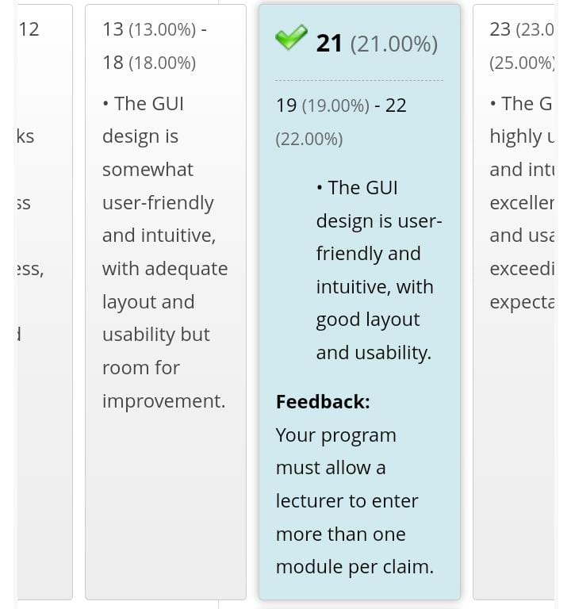

**Part 2 screenshots**



